**COMP 3059 – Capstone Project I**

**Software Requirements Analysis and Design Assignment**

This assignment is an overview to gather the software needs with requirements analysis and help to proceed with the design.

The requirements analysis helps to break down functional and non-functional requirements to a basic design view to provide a clear system development process framework. It involves various entities, including business, stakeholders and technology requirements.

The design is the activity following requirements specification and before programming. Software design usually involves problem solving and planning a software solution.

To work on this assignment you could use the references and a sample template given below. The sample template can be customised to suit the nature of your project.

Reference Readings/Example:

<http://www.uacg.bg/filebank/acadstaff/userfiles/publ_bg_397_SDP_activities_and_steps.pdf>

[www.cse.msu.edu/~chengb/RE-491/Papers/SRSExample-webapp.doc](http://www.cse.msu.edu/~chengb/RE-491/Papers/SRSExample-webapp.doc)

Source for this template:

[www.tricity.wsu.edu/~mckinnon/cpts322/cpts322-srs-v1.doc](http://www.tricity.wsu.edu/~mckinnon/cpts322/cpts322-srs-v1.doc)

# 1.0 Introduction

This section introduces the HomeEase system, emphasizing its role in delivering at-home services via a web-based platform, specifically catering to elderly and disabled users.

## Purpose

This document defines the high-level software requirements for the HomeEase system, focusing on what the system will achieve rather than the implementation details. Intended for developers, project managers, and stakeholders, it sets the foundation for system design and development.

## Scope

The HomeEase platform aims to provide convenient, reliable access to a range of home services, including plumbing, cleaning, and electrical work. Its primary objectives include:

* Enhancing convenience for elderly and disabled users
* Offering a streamlined booking and payment system
* Providing a platform for skilled service providers to connect with clients

**Out Of Scope:**

* AI-driven service matching or recommendations.
* Integration with third-party IoT devices.
* Health Services and Pet grooming services are not included.

# System Overview

This section provides context, perspective, and design constraints for HomeEase.

## Project Perspective

HomeEase is a new, self-contained system designed to address the challenges of accessibility and convenience in the home services market for elderly and disabled users.

## System Context

HomeEase operates as a user-centric platform where elderly individuals can easily book and pay for at-home services. It will ensure a user-friendly interface that allows easy navigation, secure transactions, and a feedback mechanism. Service providers benefit from a continuous stream of clients, without bearing the burden of marketing costs.

## General Constraints

* The platform must comply with legal standards and local regulations for at-home service providers (e.g., background checks for service providers, licensing requirements for specific services). This affects design and implementation as these checks need to be integrated into the platform.
* Since the primary users are elderly individuals, the user interface must be highly accessible, incorporating larger fonts, simple navigation, and possible support for assistive technologies. This affects specification and design to ensure user-centricity.
* Integration of secure payment gateways requires adherence to PCI-DSS compliance, impacting design, implementation, and testing phases, as data encryption and secure processing must be implemented and thoroughly tested.
* User and transaction data must be stored securely, adhering to GDPR or similar data privacy regulations. This constraint impacts the specification, design, and testing of data storage and handling.

## Assumptions and Dependencies

### ASSUMPTIONS

* **Reliable Availability of Service Providers**: It is assumed that a sufficient number of service providers will be available in each targeted region to meet user demand. This is essential for ensuring timely service fulfillment and maintaining a high user satisfaction rate.
* **Regular Platform Updates**: The platform will undergo continuous updates to enhance security, add functionality, and improve user experience. It is assumed that these updates will be manageable without significantly disrupting service availability.
* **User Participation in Feedback Mechanisms**: It is assumed that users will actively participate in the review and rating system, which is crucial for maintaining service quality and accountability. This feedback loop will help users make informed decisions and motivate service providers to uphold high standards.

### DEPENDENCIES

* **Third-Party Payment Gateway**: The platform depends on a secure, reliable third-party payment gateway for processing transactions. The availability and performance of this gateway directly impact the user experience during payment.
* **Compliance with Local Regulations**: Service availability and provider onboarding are dependent on compliance with local laws and regulations related to at-home services. Any changes in regulatory standards could impact service offerings and provider qualifications.
* **Hosting and Infrastructure Services**: The platform’s performance and availability depend on reliable cloud hosting and infrastructure providers. Consistent uptime and performance of these services are critical for delivering a seamless user experience.

## 3.0 Functional Requirements

# User Registration and Login

* **Introduction**: Users must be able to create accounts and log in securely.
* **Inputs**: Username, password, user type (service provider or customer).
* **Processing**: Secure login with password encryption.
* **Outputs**: Access to personalized dashboard.

# Service Browsing and Booking

* **Introduction**: Users can browse services and book appointments based on availability.
* **Inputs**: Service category, date and time, user’s location.
* **Processing**: Displays available service providers, handles booking confirmation.
* **Outputs**: Booking confirmation details with provider information.

**Secure Payment Processing**

* **Introduction**: Users can make payments within the platform for booked services.
* **Inputs**: Payment details, amount.
* **Processing**: Processes payments through an external secure gateway.
* **Outputs**: Confirmation of successful transaction.

# Service Provider Management

* **Introduction**: Service providers can create profiles and manage service offerings.
* **Inputs**: Service details, provider availability.
* **Processing**: Stores provider information and updates availability.
* **Outputs**: Visible provider profile for potential customers.

# Review and Rating System

* **Introduction**: Customers can leave feedback for service providers.
* **Inputs**: Rating, comments.
* **Processing**: Stores and displays ratings to maintain service quality.
* **Outputs**: Updated provider profile with feedback.

## 3.2 Use Cases

### 3.2.1 Use Cases

#### ****Use Case #1: Elderly User Books a Plumbing Service****

* **Primary Actor**: Elderly User
* **Preconditions**:
  + The user must be logged into the HomeEase platform.
  + There must be available plumbing services listed in the system.
* **Triggers**: The user selects the plumbing service category and initiates a booking.
* **Basic Flow**:
  + The user navigates to the service categories and selects "Plumbing."
  + The system displays available plumbing services and providers, along with ratings and prices.
  + The user chooses a preferred service and clicks "Book Now."
  + The system prompts the user to select a date and time for the service.
  + The user confirms the booking details.
  + The system processes the booking and displays a payment prompt.
  + The user completes the payment through the secure payment gateway.
  + The system confirms the booking and notifies the user with the booking details.
* **Postconditions**:
  + A booking record is created and stored in the system.
  + The service provider is notified of the new booking request.
* **Alternative Flows**:
  + **Payment Failure**: If payment fails, the system informs the user and offers options to retry or cancel the booking.
  + **No Availability**: If no plumbers are available at the selected time, the system prompts the user to select another time.

#### ****Use Case #2: Service Provider Receives and Confirms a Booking Request****

* **Primary Actor**: Service Provider
* **Preconditions**:
  + The provider must have an active profile on the HomeEase platform.
  + The provider is available and has enabled notifications.
* **Triggers**: The system sends a notification to the provider for a new booking request.
* **Basic Flow**:
  + The provider receives a booking notification and logs into the platform.
  + The system displays booking details, including user information, requested service, and scheduled time.
  + The provider reviews the booking details and confirms availability.
  + The provider clicks "Confirm Booking" to accept the request.
  + The system updates the booking status to "Confirmed" and notifies the user.
* **Postconditions**:
  + The booking is confirmed and saved in the system.
  + The user receives a notification that the service is confirmed.
* **Alternative Flows**:
  + **Provider Unavailable**: If the provider cannot fulfill the request, they can decline it, and the system will notify the user to select another provider.
  + **Booking Cancellation**: If the provider cancels after confirmation, the system notifies the user and offers rescheduling options.

**3.3 Data Modelling and Analysis**

* **Normalized Data Model Diagram**

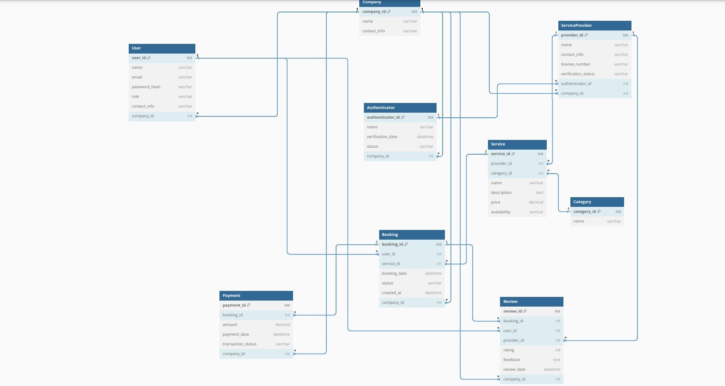

* **Activity Diagrams**

**1.Login User**

**2.Login Service Provider**

**3.System assigning task**

* Sequence Diagrams
* UML Class Diagram

**3.4 Process Modelling**

* Data Flow Diagram

## 4.0 Non-Functional Requirements

**Performance**:  
The platform should support up to 5,000 concurrent users with a response time of less than 5 seconds for all primary actions, including service browsing, booking, and payment processing.

**Reliability**:  
The system must ensure 99.9% uptime with automated failover and recovery mechanisms to minimize downtime. Recovery processes should be fast and transparent to users.

**Availability**:  
HomeEase will be available 24/7, with scheduled maintenance windows communicated in advance to users via email and on the platform. During maintenance, users will be informed about service unavailability and expected resolution times.

**Security**:  
SSL/TLS encryption will be used for all data in transit, ensuring secure communication between users, providers, and the platform.

**Maintainability**:  
The platform’s architecture should be modular, allowing easy updates, bug fixes, and the addition of new features without significant rework. Clear coding standards, documentation, and version control will be maintained to ensure maintainability by current and future developers.

**Portability**:  
The HomeEase platform will be accessible on multiple platforms, including web browsers (Chrome, Firefox, Safari, Edge). The system will be responsive and optimized for both desktop and mobile interfaces to ensure a consistent user experience across devices.

## 5.0 Logical Database Requirements

**Support large volumes of user data, service records, and transaction logs**:  
The system should be able to scale to handle a growing amount of data, including user profiles, service requests, booking history, and payment transactions.

**Ensure data retention for a minimum of 5 years for financial transactions**:  
All financial transaction data (including payments, refunds, and invoicing) must be retained securely for at least five years, in compliance with local regulations and industry standards.

**Maintain data integrity with ACID compliance**:  
The database must support ACID (Atomicity, Consistency, Isolation, Durability) properties to ensure reliable processing of critical data, especially for booking and payment transactions. This ensures that the data is consistent, even in the event of failures or system crashes.

## 6.0 Other Requirements

1. Compliance with accessibility standards to support elderly and disabled users.

2. Robust logging and monitoring to track system performance and security issues.

**7.0 Approval**

The signatures below indicate their approval of the contents of this document.

|  |  |  |  |
| --- | --- | --- | --- |
| Project Role | Name | Signature | Date |
| Project Manager | Bhavya Vaghela |  |  |
|  |  |  |  |
|  |  |  |  |